Images and Alt text: 25 <https://drive.google.com/drive/folders/1f9MsTJliUxo1LvXr2SobWotehOeQidqU?usp=sharing>

Slug: linkedin-auto-connect-tools

Grammarly: 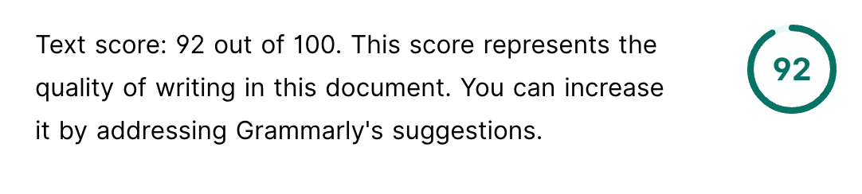

Hemingway: 

KD: 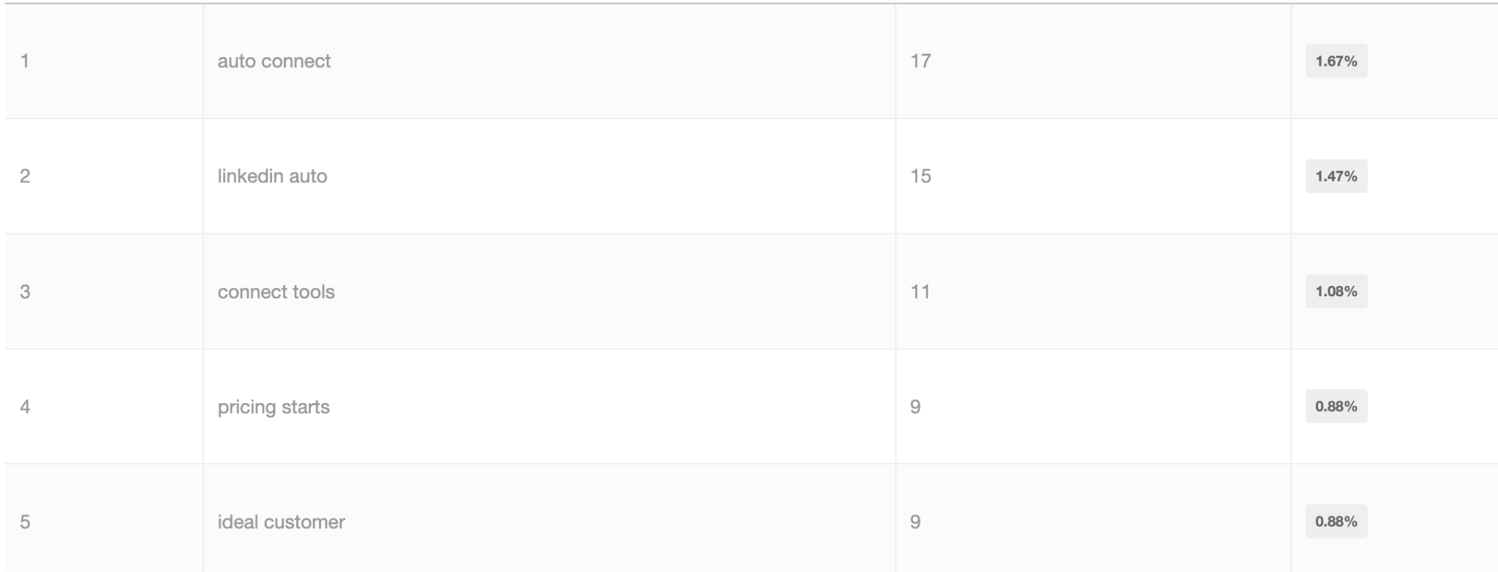

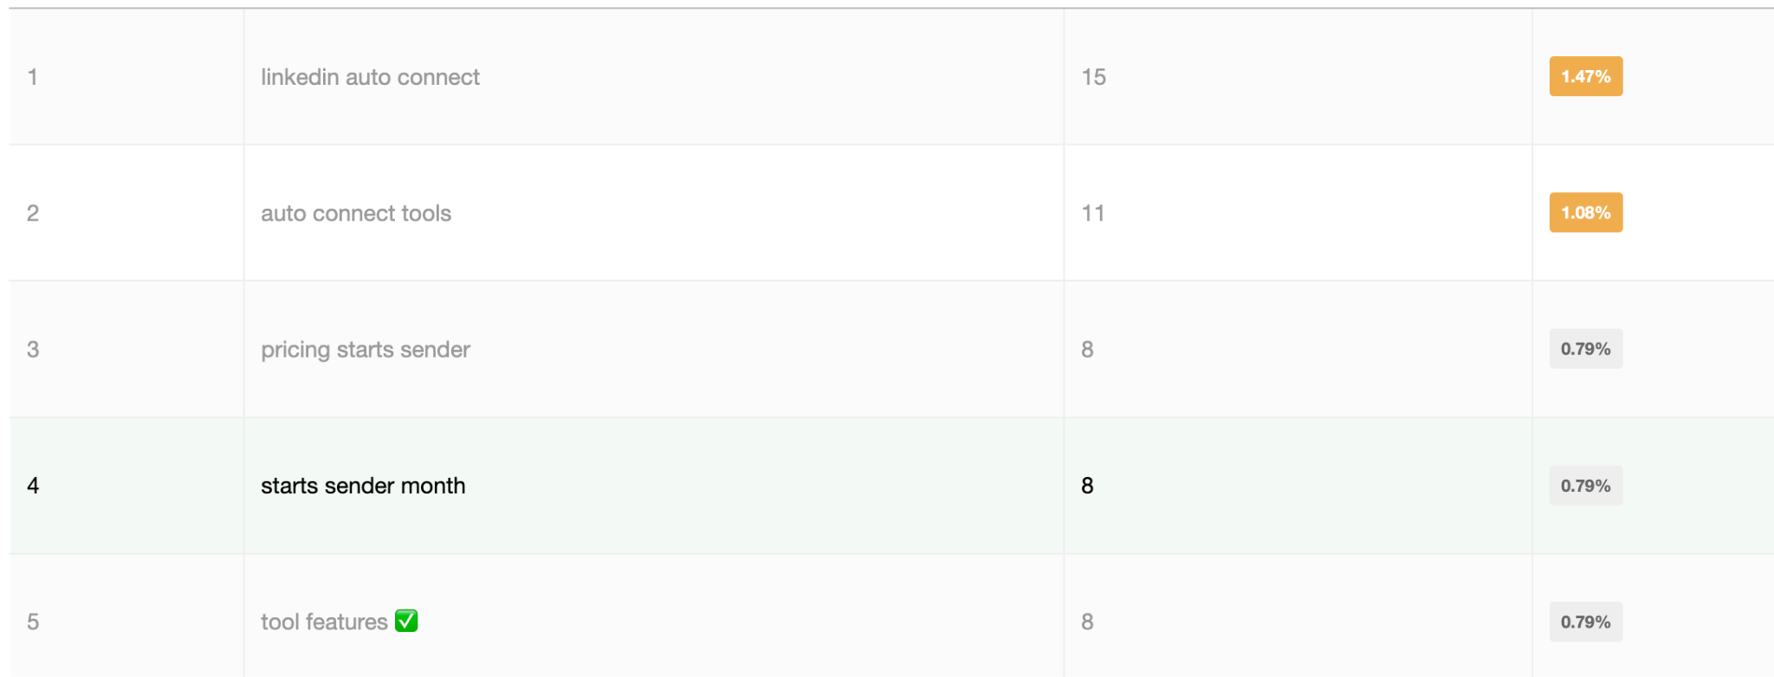

Copyleaks: 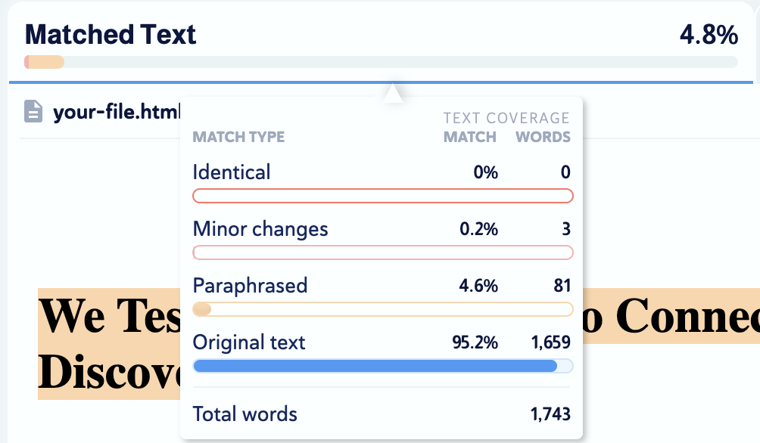

Meta: Find the 9 best LinkedIn auto connect tools for any budget. Learn about safety, legality, and top features to boost your outreach and save time. Read now!

# We Tested 9 LinkedIn Auto Connect Tools (Here’s What We Discovered)

**You should read this blog…**

If you are trying to find the best LinkedIn auto connect tool but don’t even know where to start.



I’ve been there.

After spending **5 years testing, tweaking, and even** [**building my own**](https://www.salesrobot.co/)LinkedIn auto connect tool, I’ve finally rounded up the **9 tools that actually work**.

If you **skip this blog**, you might end up with a tool that’s **overpriced, unsafe, or flat-out ineffective**.

And I know **money matters**, too.

That’s why I’ve included **tools for every budget**, so you can find the perfect fit without breaking the bank.

In this blog, I’ll also answer the big questions:

* **Are these tools legal?**
* **Are they even safe?**

Plus, I’ll dive deep into the **types of LinkedIn auto connect tools**, how they work, and**the top benefits****.**

With that being said, lets quickly go through the tools that we will cover:  
  
1. SalesRobot

2. MeetAlfred

3. HeyReach

4. Expandi

5. LaGrowthMachine

6. Skylead

7. Dripify

8. Evaboot

9. LinkedIn Helper 2

Let’s jump in!

## What Are LinkedIn Auto Connect Tools?

LinkedIn auto connect tools help you send connection requests on LinkedIn without lifting a finger.

Remember when you had to **spend hours clicking “connect” over and over?**

**Not anymore!** These tools handle it for you.

They make **reaching out to new people fast, easy, and way less boring**.

It’s like having your own little helper who knows exactly who you want to connect with and takes care of it while you focus on more important things.

### Is LinkedIn automation legal?

LinkedIn might not *like* these tools, they’re **totally fine to use.**

Just make sure **you’re using them the right way**, and you’ll be good to go!

### Is LinkedIn automation safe?

**Yes**, LinkedIn automation tools are safe!

The key is to use them wisely. **Stick to the recommended limits, and your account will stay completely safe**.

Safety also depends on the type of tool you are using and that is exactly what we are going to talk about next.

## 3 Types of LinkedIn Auto Connect Tools

There are **three types** of LinkedIn auto connect tools available in the market, and **each one works a little differently.**

*Let me quickly break them down for you!*

### 1. Chrome Based

These tools sit on top of your browser and do all the automation with a touch of a click. These are Chrome extensions and can be downloaded from the Chrome Store.

***Here’s what’s good about them:***

* Cheap and affordable
* Super easy to set up.

***Here’s what’s NOT good about them:***

* You have to keep your browser open for it to work.
* Your LinkedIn account can get banned.



### 2. Cloud Based

These tools **run on dedicated servers** and **don’t need anything installed** on your browser or computer.

***Here’s what’s good about them:***

* Works even when your computer is off
* Handles multiple accounts easily
* More secure with proxies and VPNs
* Keeps your LinkedIn account safe

***Here’s what’s NOT good about them:***

* Might trigger LinkedIn's API a lot



### 3. Desktop Based

These tools run **directly from your computer with an app** that you install.

***Here’s what’s good about them:***

* Uses your personal IP address
* Can handle multiple LinkedIn accounts

***Here’s what’s NOT good about them:***

* Won’t work if your computer is turned off
* No remote access



While you weigh the pros and cons of each type, let's talk about…

## 4 Benefits of LinkedIn Auto Connect Tools

### 1. LinkedIn Messaging Automation

**Generating leads via outbound** is common, but people do it **manually.**

With LinkedIn auto connect tools, you can **automate your outreach on LinkedIn.**

*You can automate steps like:*

* Viewing profiles
* Sending connection requests
* Sending LinkedIn messages and InMails
* Scheduling and sending follow-ups

And it gets even better with **advanced features** like:

* Send a follow-up after a certain action

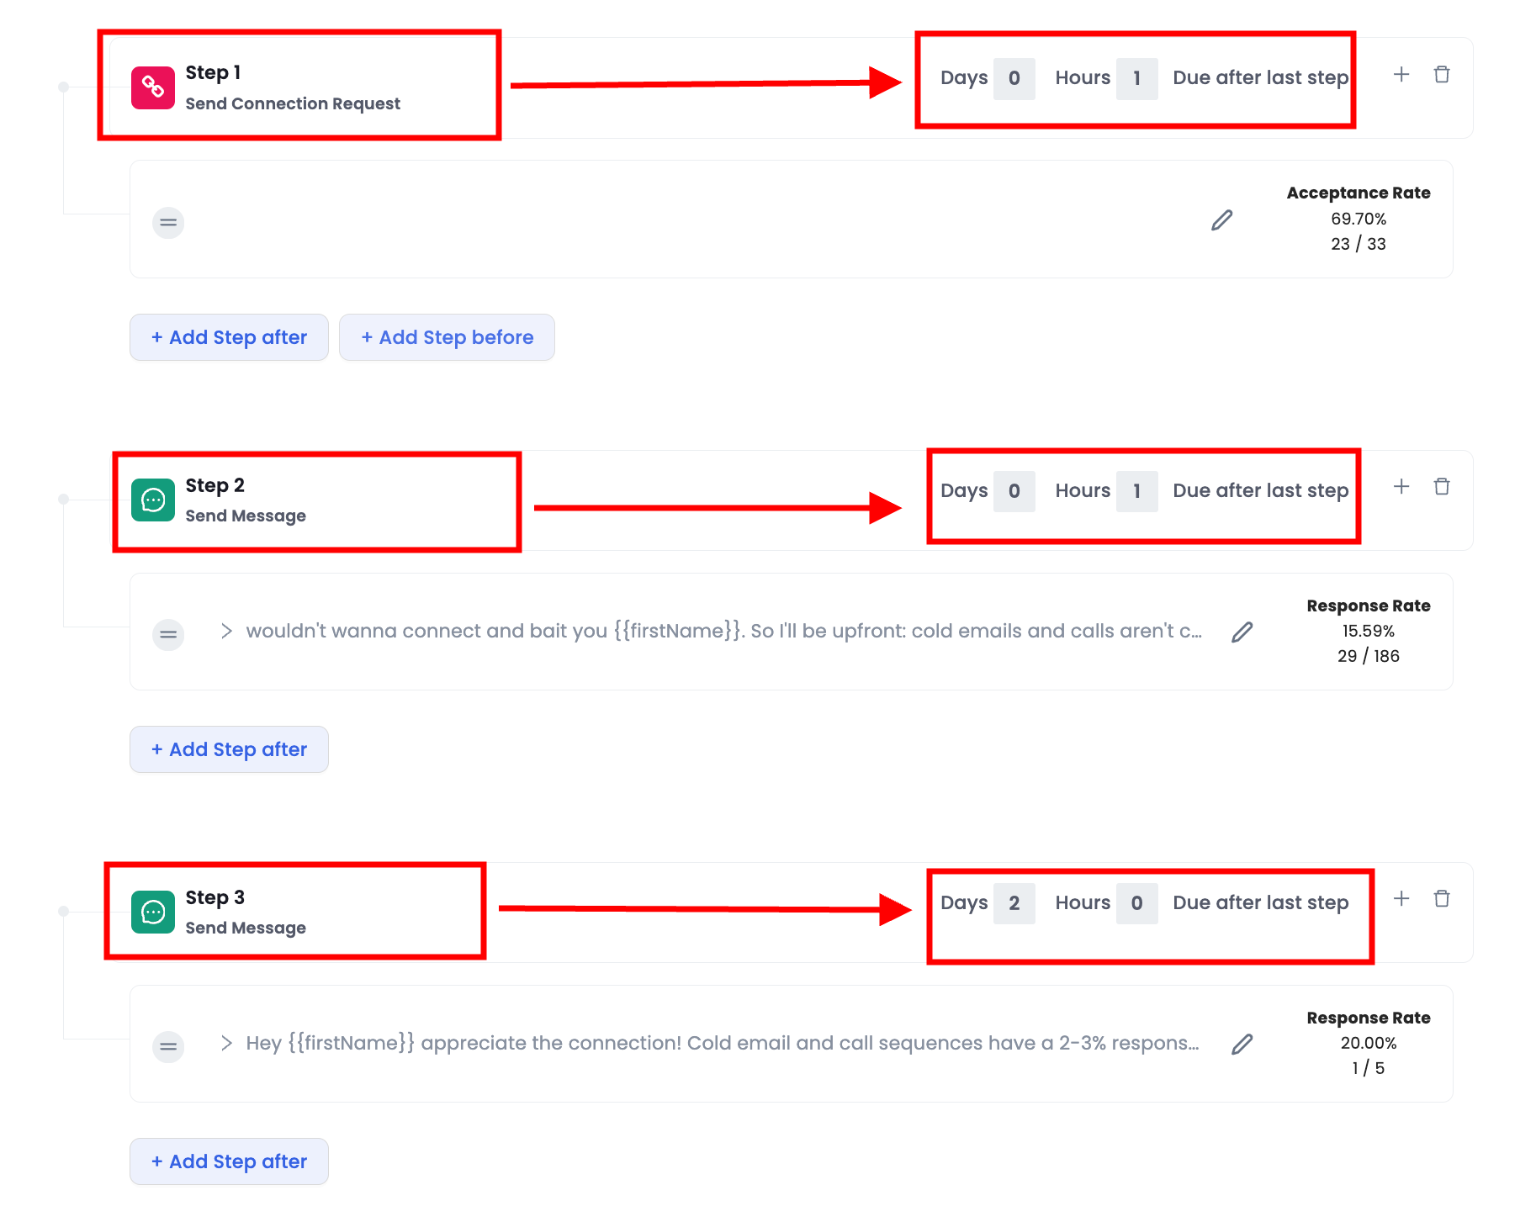

* Personalize your messages with variables

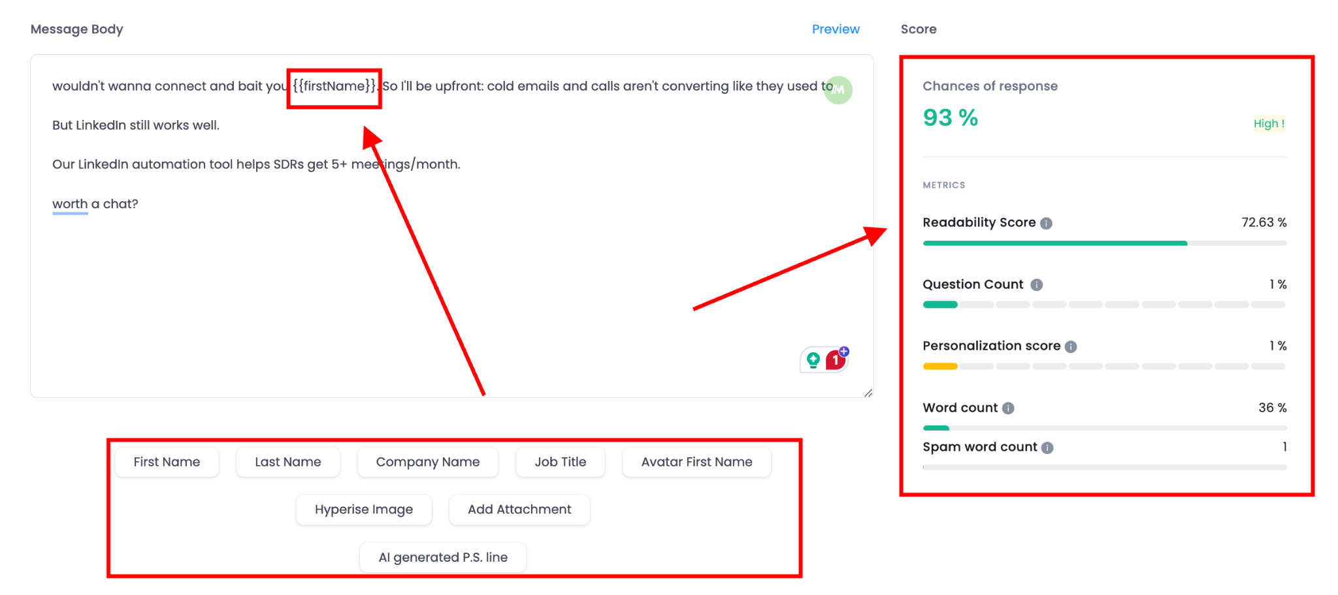

### 2. LinkedIn Scraping

Data is everything, and without it, doing business is nearly impossible.

LinkedIn auto connect tools make **extracting valuable data from LinkedIn** **or Sales Navigator searches easier.**

They help you find necessary details like:

* Emails
* Full names
* Company names
* LinkedIn profile URLs and more

Since LinkedIn doesn’t allow you to export leads directly, you’ll need a third-party tool to grab this data.

But some people may say it’s common to extract data with one tool and then upload it into a LinkedIn auto connect tool. **Don’t do that.**

Always choose a tool that lets you **scrape LinkedIn Sales Navigator directly and manage your outreach in the same place.**

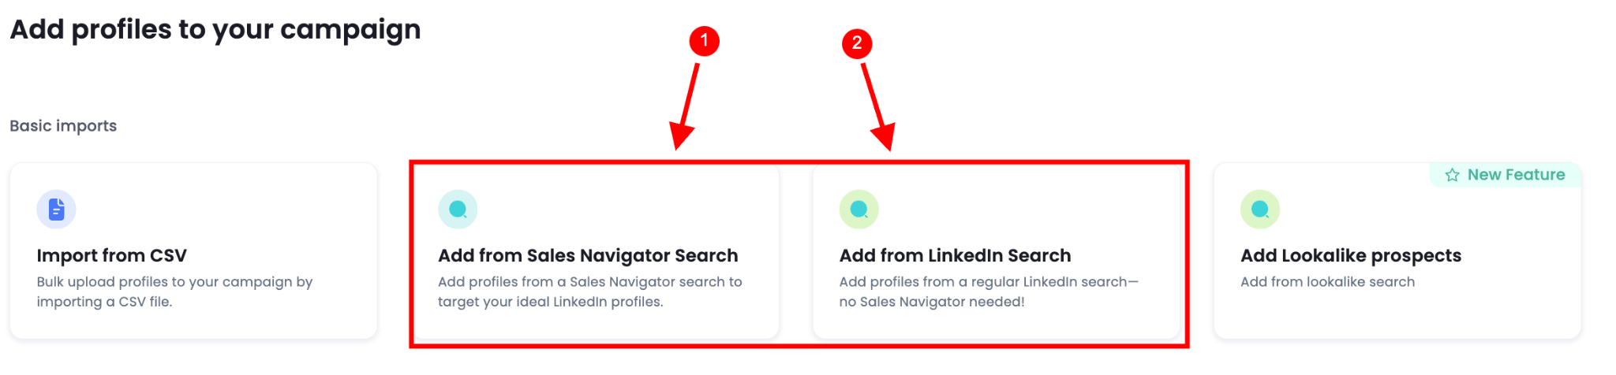

That way, you’ll keep everything streamlined and secure.

### 3. Multichannel Outreach

If your **prospect does not revert to you on LinkedIn**, you can always **send them a reminder email. *How?***

With Auto connect tools, you can **combine LinkedIn messages and cold emails.**

They’re **complex but super powerful.**

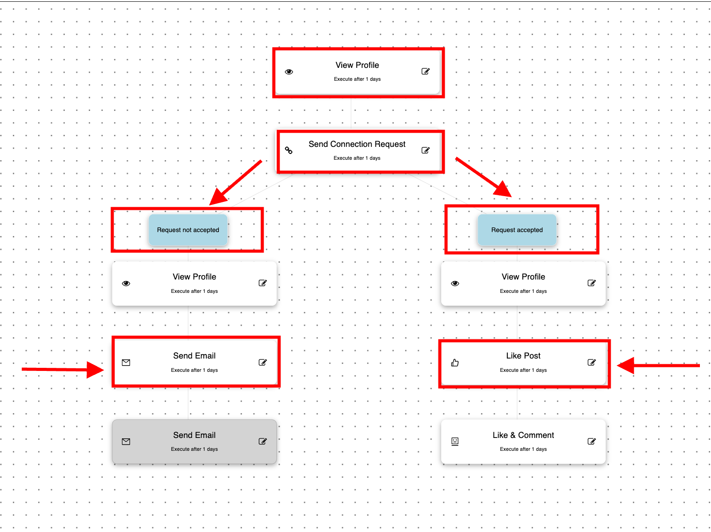

With a multichannel outreach tool, you can automate almost every step of your sales process.

### 4. LinkedIn Marketing Automation

If you are into **creating LinkedIn content,** these tools are for you.

They help you automate tasks to **help with social selling on LinkedIn.**

* Publish LinkedIn posts
* Gather likes and comments for your posts

And now, it’s time to find out which tool falls into which category.

## 9 LinkedIn Auto Connect Tools To Try in 2025

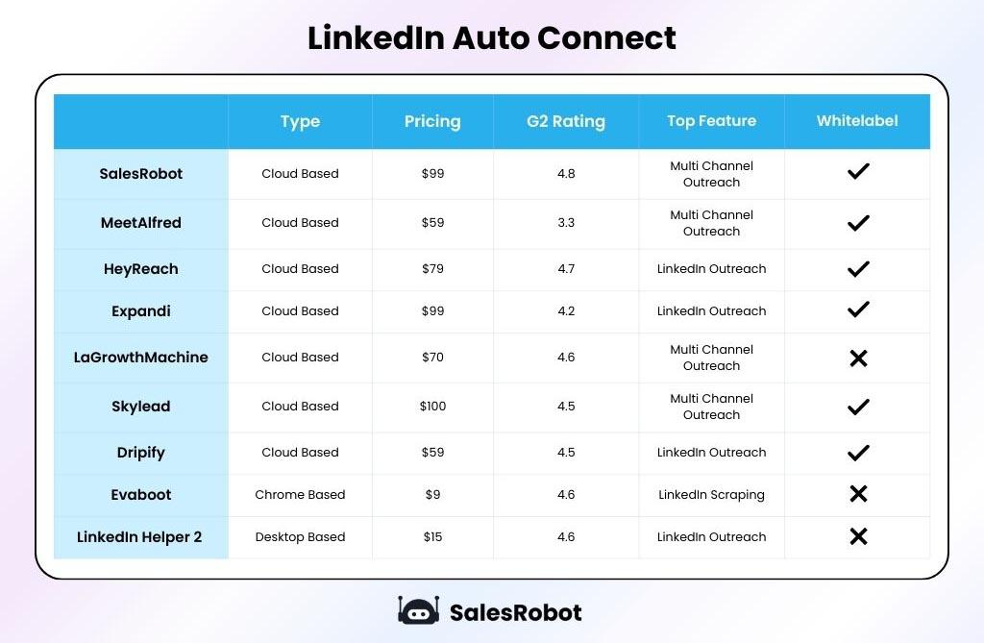

### 1. SalesRobot

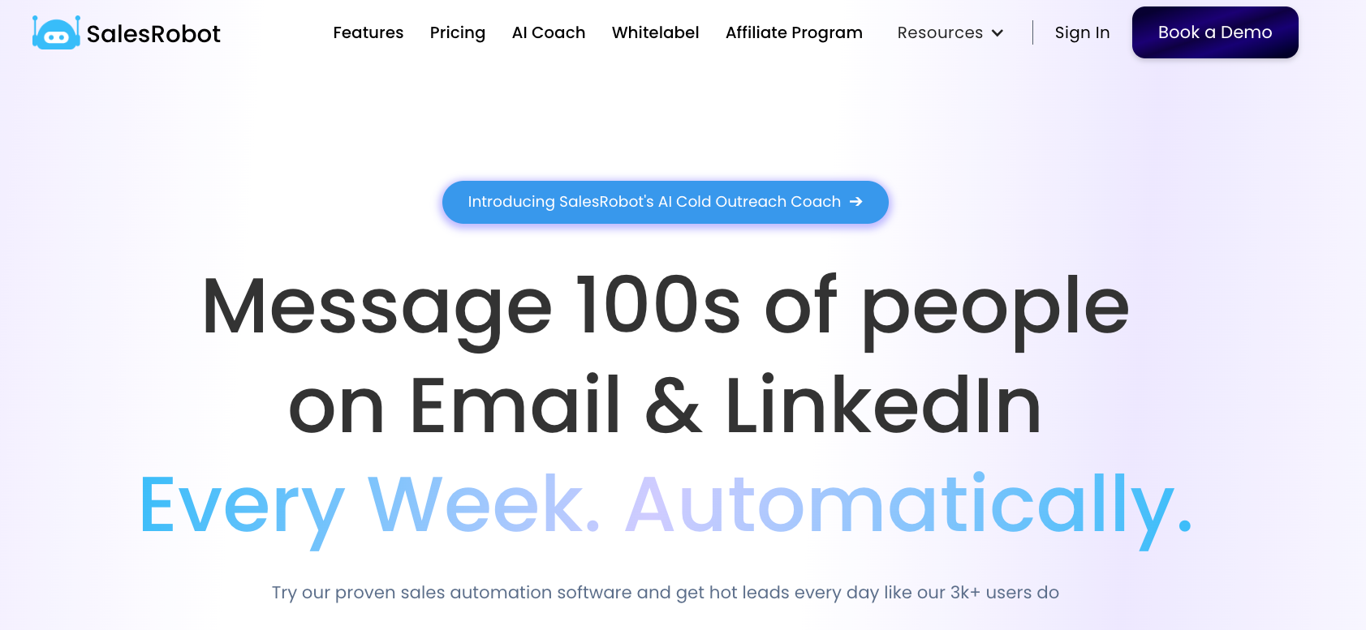

[SalesRobot](https://www.salesrobot.co/) is **cloud based** that helps you automate your LinkedIn and email outreach. It is an all-in-one LinkedIn auto connect tool.

**Top Features -**

✅ AI powered **Cold outreach assistant -** [**SalesGPT 2.0**](https://www.salesrobot.co/salesgpt-2-0)



✅ **Send up to 200+ connection requests every week on LinkedIn**

✅ **Find and** **enriches verified work email addresses**

✅ **Send cold emails within the same sequence.**

**✅ Safe mode to protect your account**

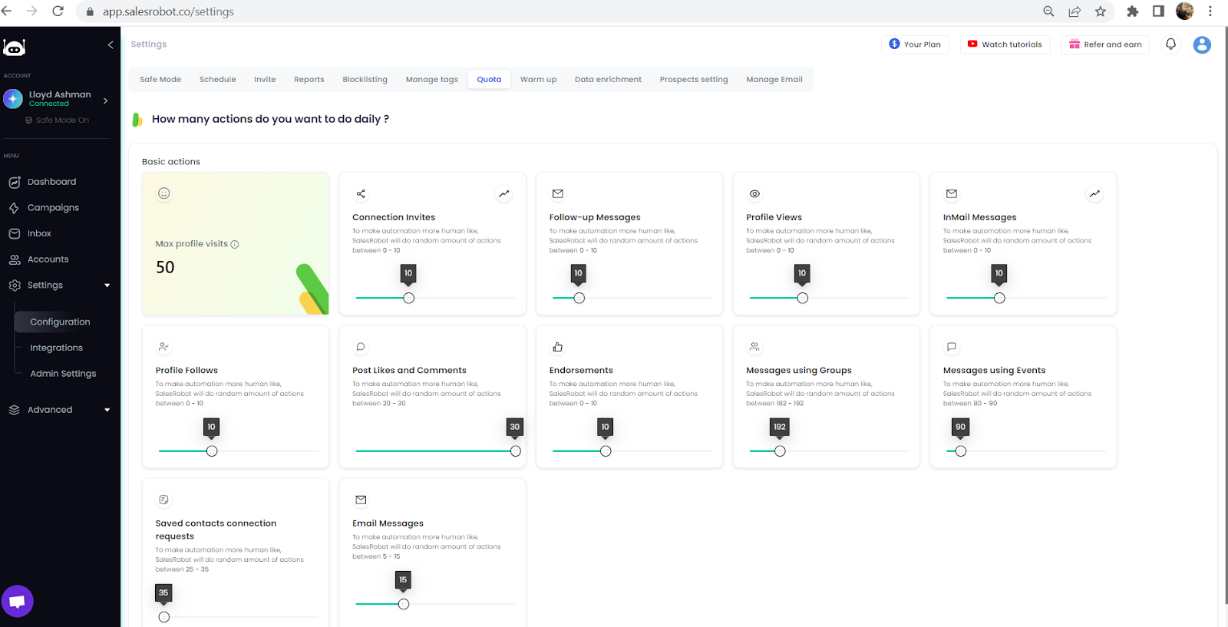

✅ **Around-the-clock customer support***(even on weekends)*

✅ **Manage your LinkedIn and email inbox** from one place

✅ Work **email enrichment and verifier.**

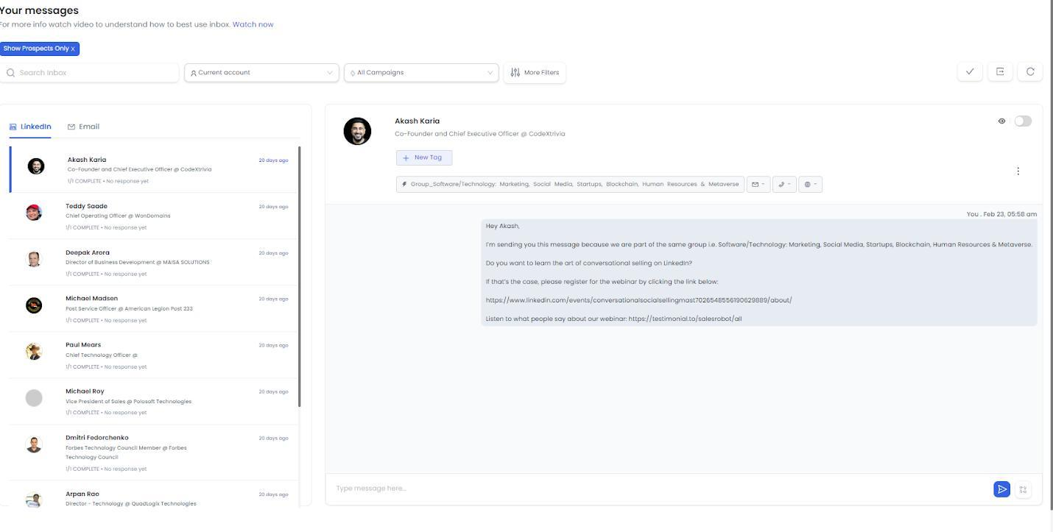

✅ Easy integration to popular tools such as [**Zapier**](https://zapier.com/)**,** [**HubSpot**](https://www.hubspot.com/products/crm)**,** [**Salesforce**](https://www.salesforce.com/in/)**, and** [**Hyperise**](https://hyperise.com/)**.**

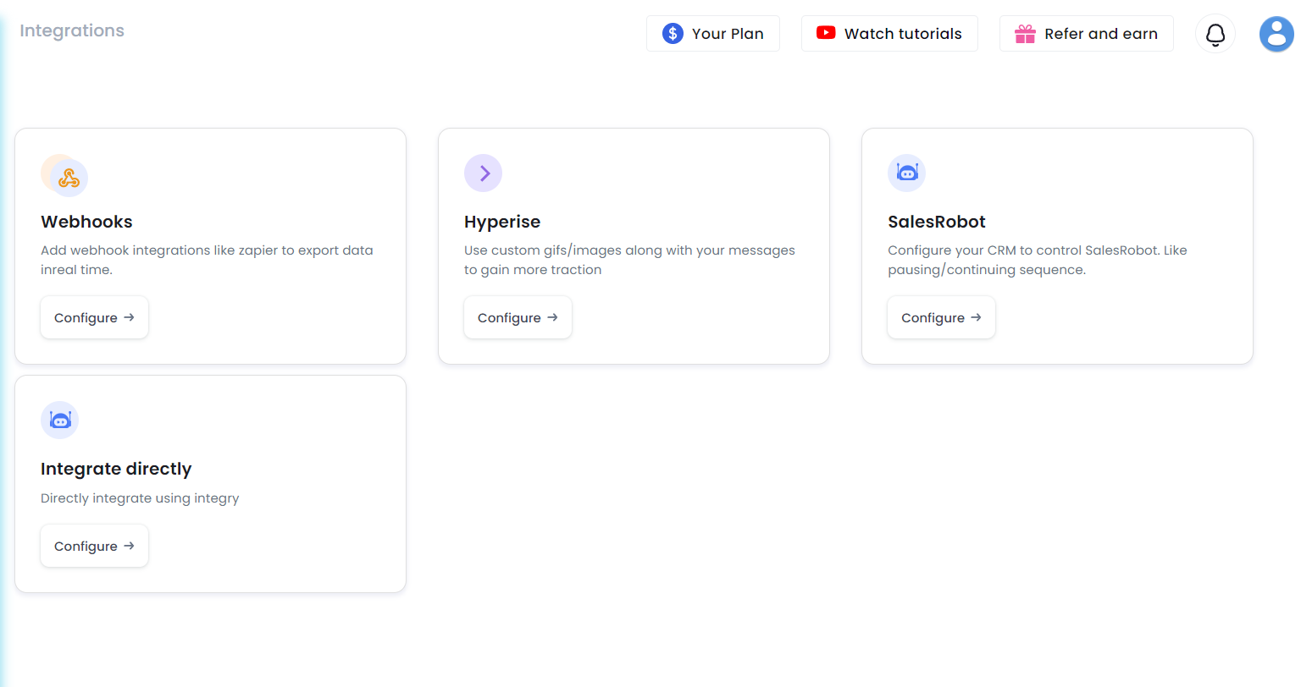

**Ideal Customer -** Solorprenuers, freelancers, startup sales professionals, small businesses, and marketing agencies.

**Pricing -** Starts at $99/sender/month (save 20% with annual plan)

[Rated 4.6/5 on G2](https://www.g2.com/products/salesrobot/reviews)

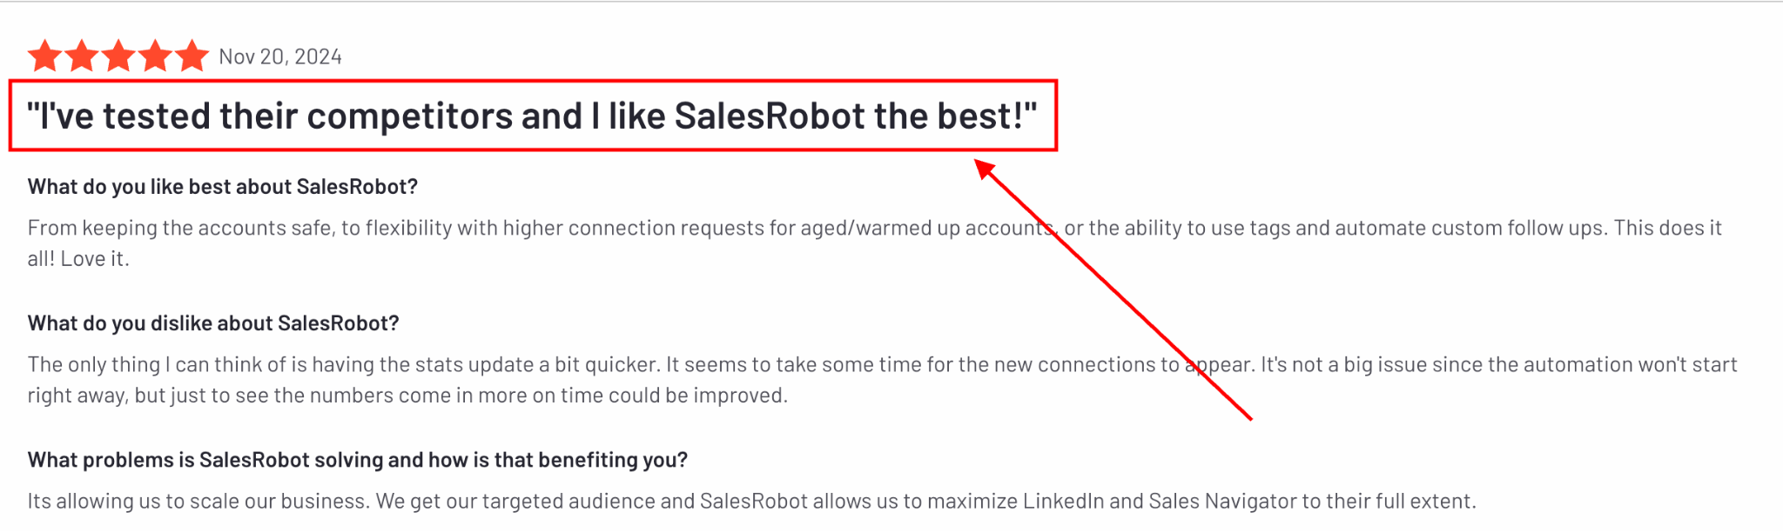

### 2. MeetAlfred

[Meet Alfred](https://www.salesrobot.co/blogs/meet-alfred-alternatives) is a tool lead generation tool that, unlike other tools, **works across multiple social media platforms at the same time**, making it perfect for running campaigns on different channels.

It is a cloud based tool.

<https://www.youtube.com/watch?v=VOUBaTMGpDU>

**Top Features -**

✅ **Generate leads via multiple platforms**, exLinkedIn, Facebook, X, etc.

**✅ Schedule and preview posts.**

✅ **Warm up LinkedIn and email accounts.**

✅ Account remains safe since it **mimics human activity.**

**Ideal Customer -** Marketers and teams managing multichannel outreach.

**Pricing** - Starts at $59/sender/month

[Rate 3.3/5 on G2](https://www.g2.com/products/meetalfred-com/reviews)



### 3. HeyReach

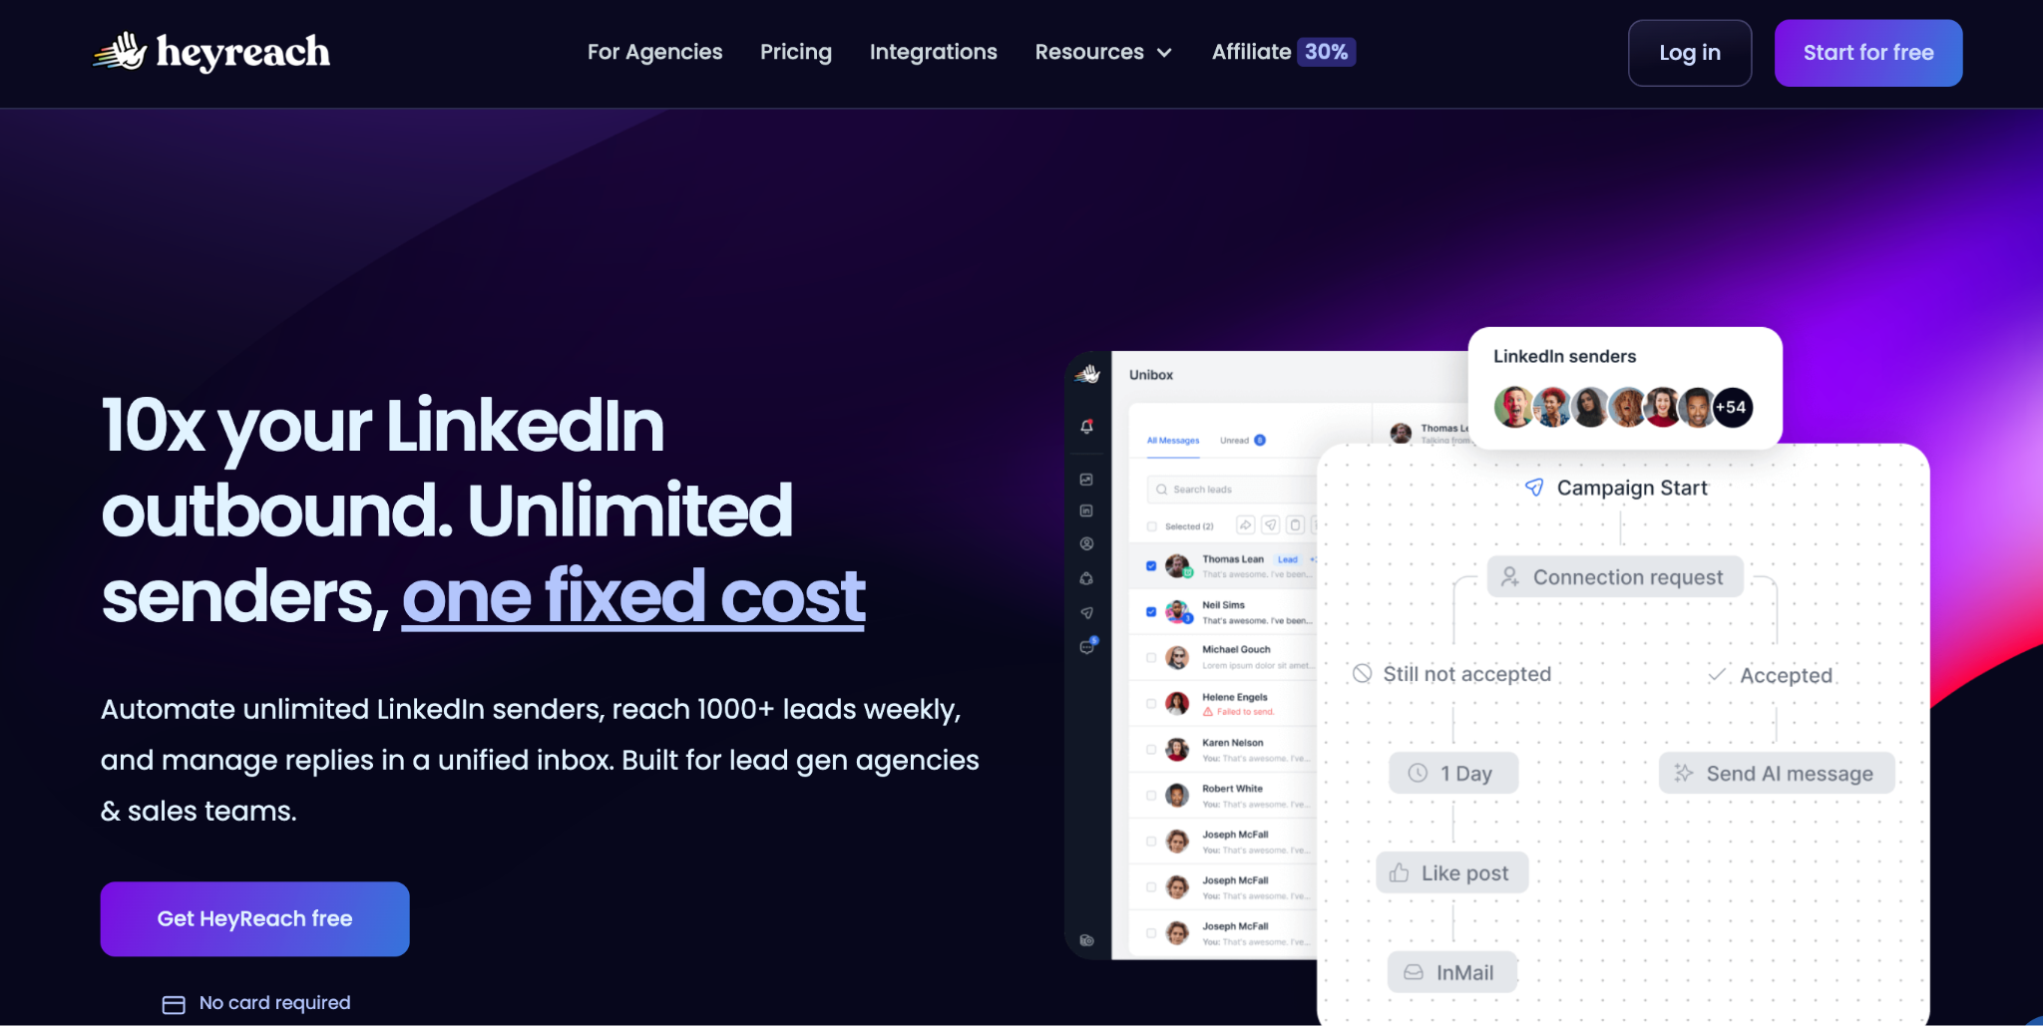

[HeyReach](https://www.salesrobot.co/blogs/heyreach-alternatives) is a LinkedIn automation tool that helps you save time. It i**s limited to LinkedIn only**, with no cold email automation.

It is a cloud based tool.

**Top Features -**

**✅ Connect multiple accounts** to scale your outreach.

**✅** Create **complex outreach sequences.**

**✅ Integrate your favorite CRM**.

**Ideal Customer -** Freelancers and startups

**Pricing** - Starts at $79/sender/month

[Rate 4.7/5 on G2](https://www.g2.com/products/heyreach/reviews)

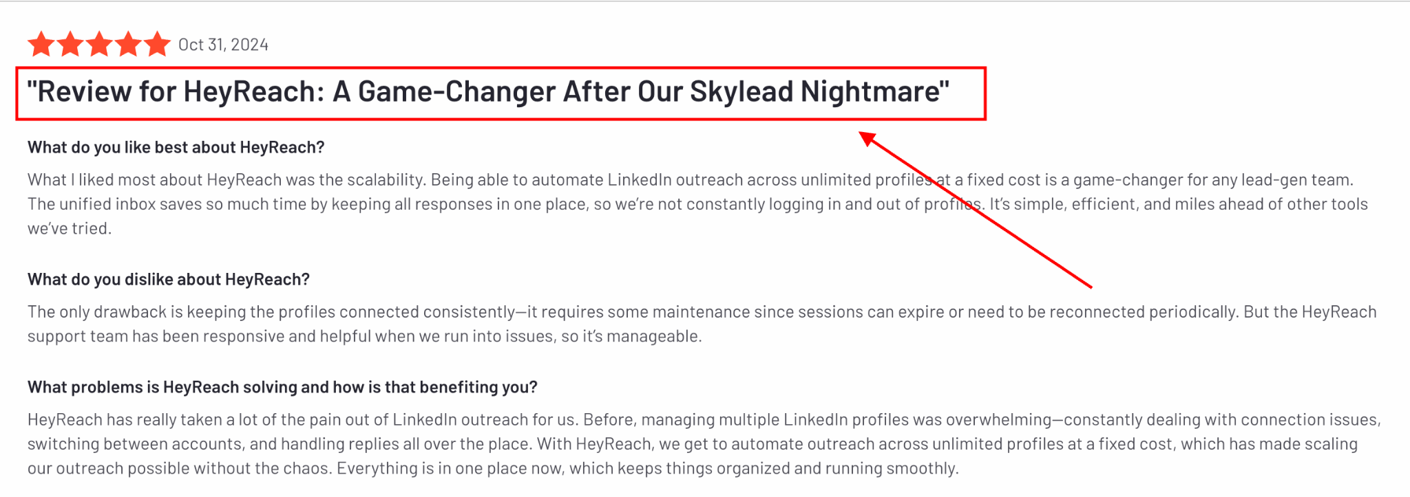

### 4. Expandi

<https://www.youtube.com/watch?v=9F98hmi8rPg>

[Expandi](https://www.salesrobot.co/blogs/expandi-review) is a secure **cloud-based tool** perfect for handling LinkedIn outreach safely, even when managing multiple accounts.

Yes, it has email automation capabilities, too.

**Top Features -**

**✅ Automates LinkedIn messaging and connection requests.  
✅** Uses **dedicated IPs to protect accounts.  
✅ Manage multiple accounts.  
✅ Advanced personalization.**

**Ideal Customer -** Agencies and consultants managing multiple accounts

**Pricing** - Starts at $99/sender/month

[Rate 4.2/5 on G2](https://www.g2.com/products/expandi-io/reviews)

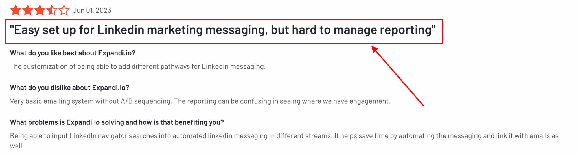

### 5. LaGrowthMachine

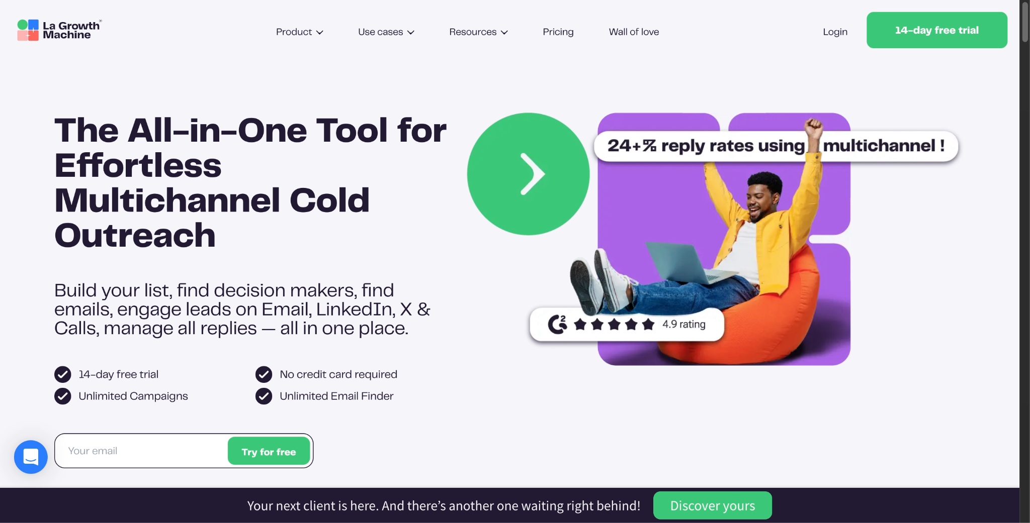

[LaGrowthMachine](https://www.salesrobot.co/blogs/lagrowthmachine-alternatives) is a **multichannel automation tool** that combines LinkedIn outreach with email campaigns, making it ideal for sales teams.

It is a cloud-based tool.

**Top Features -**

**✅** Combines **LinkedIn and email outreach** in one platform.

**✅ Pre-built templates** for quick setup.

**✅ AI voice notes** for LinkedIn

**Ideal Customer -** Sales teams looking for a multichannel tool

**Pricing** - Starts at $70/sender/month

[Rate 4.6/5 on G2](https://www.g2.com/products/la-growth-machine/reviews)

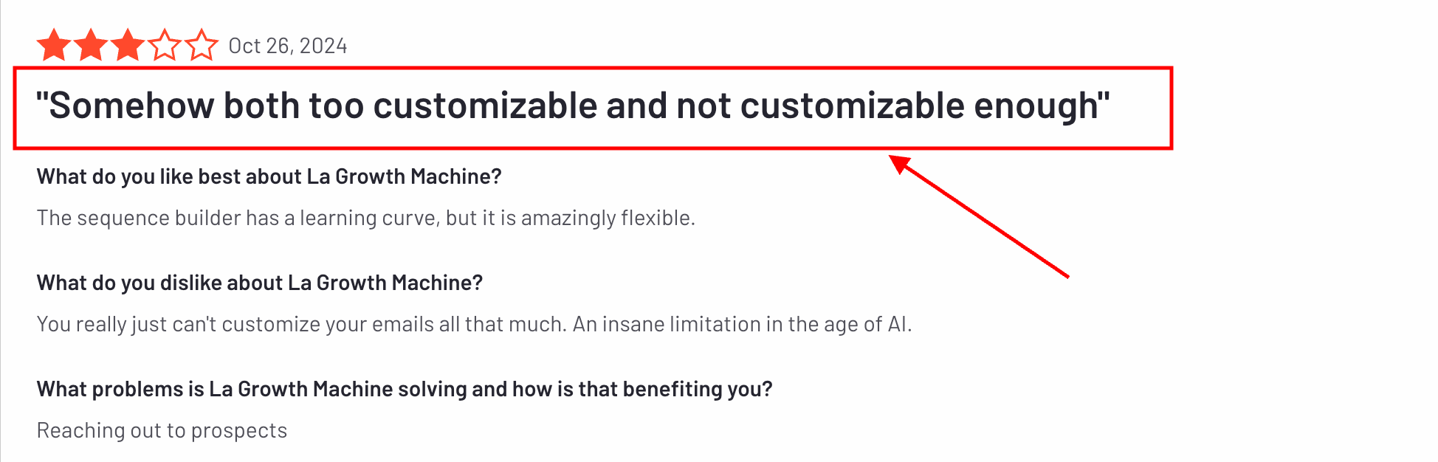

### 6. Skylead

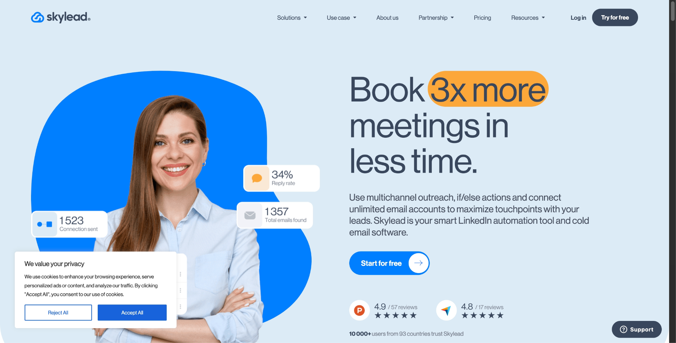

[Skylead](https://www.salesrobot.co/blogs/skylead-review) is a **LinkedIn and email automation tool** designed for users who want powerful workflows and detailed reporting.

It is a cloud-based tool.

**Top Features -**

✅ Smart **customized outreach sequences**.

✅ Ready to use **tested outreach templates.**

✅ **Email discovery and verifier.**

✅ **Image personalization.**

**Ideal Customer -** Businesses and solopreneurs

**Pricing** - Starts at $100/sender/month

[Rate 4.5/5 on G2](https://www.g2.com/products/skylead/reviews)

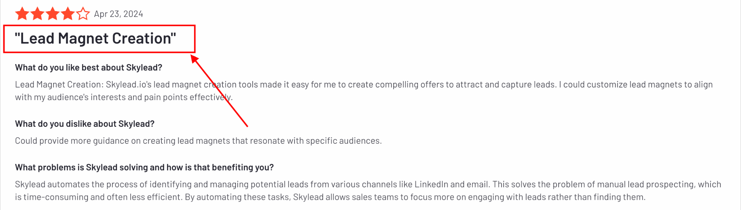

### 7. Dripify

<https://www.youtube.com/watch?v=a4Vqz4WhdAM>

[Dripify](https://www.salesrobot.co/blogs/dripify-review) is a **LinkedIn automation tool** that helps you manage drip campaigns while integrating seamlessly with CRMs.

**NO email automation.**

It is a cloud-based tool.

**Top Features -**

✅ **LinkedIn campaign creation** via CSV, LinkedIn search, and profile URL  
✅ **Manage and check sales team performance** from one place

✅ **Keeps accounts safe** by respecting LinkedIn limits.

✅ **Provides analytics** for campaign performance.

**Ideal Customer -** Sales professionals and marketers who want an affordable tool.

**Pricing** - Starts at $59/sender/month

[Rate 4.5/5 on G2](https://www.g2.com/products/dripify/reviews)

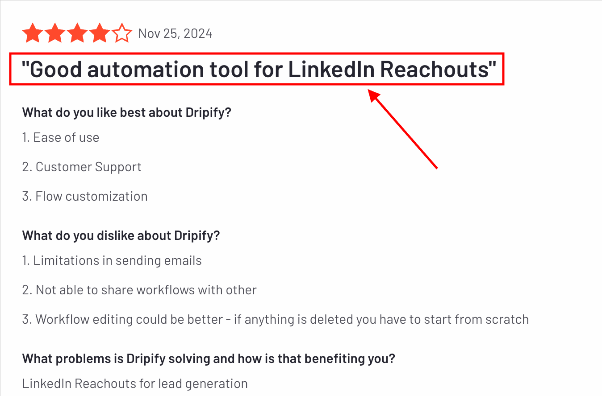

### 8. Evaboot

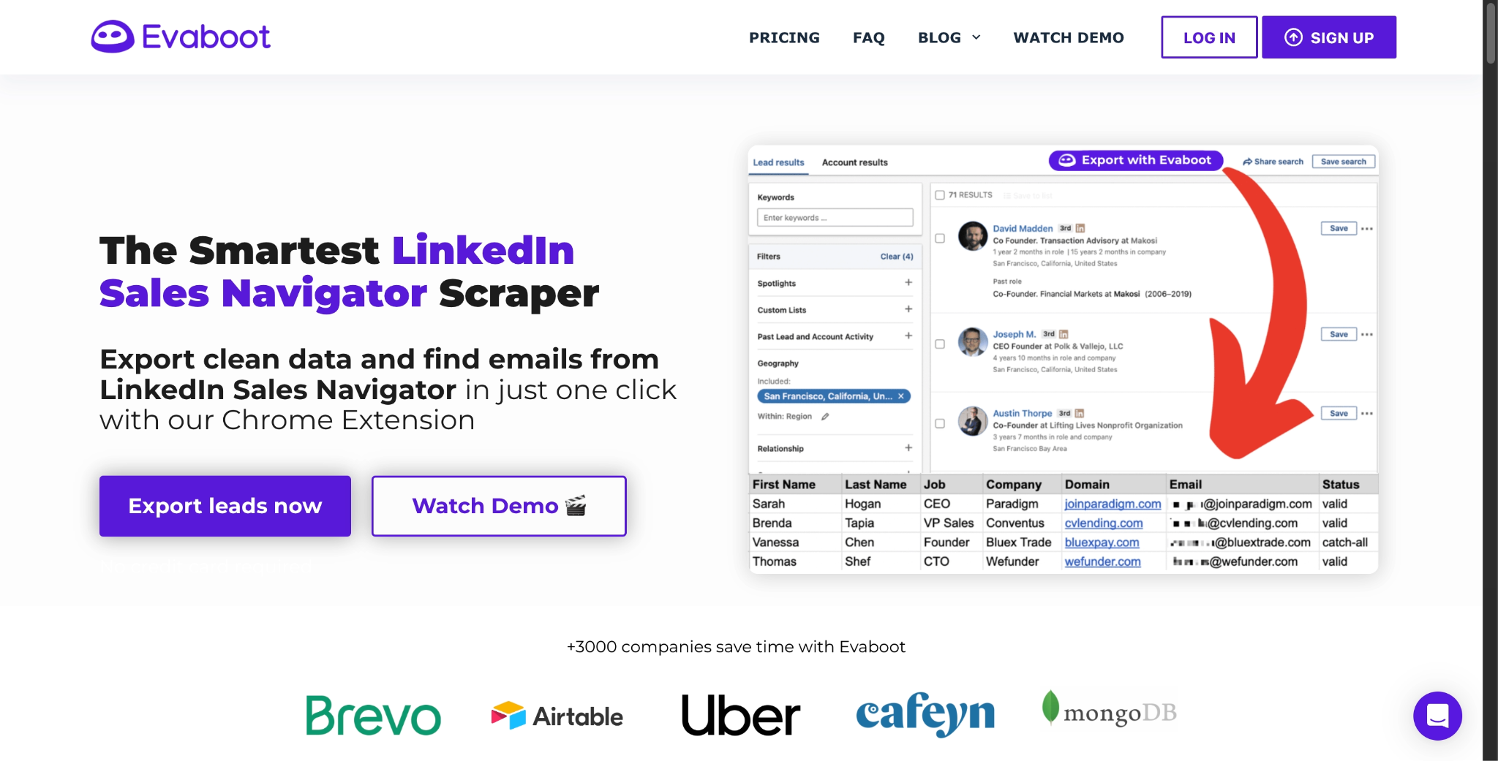

Evaboot specializes in **extracting clean data from LinkedIn Sales Navigator,** making it perfect for building accurate lead lists.

No LinkedIn or email automation.

It is a chrome based tool.

**Top Features -**

✅ **Scrapes data** from LinkedIn Sales Navigator searches.  
✅ **Cleans and organizes data.**  
✅ **Export leads to CSV.**  
✅ **FInd and verify emails.**

**Ideal Customer -** Data-focused teams and marketers requiring clean, exportable LinkedIn leads.

**Pricing** - Starts at $9/month (100 credit only)

[Rate 4.6/5 on G2](https://www.g2.com/products/evaboot/reviews)

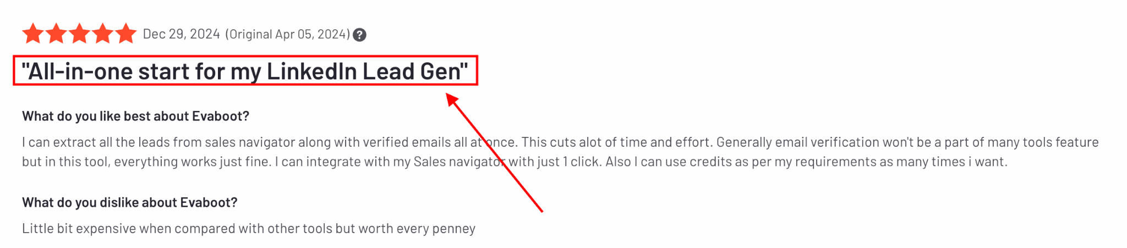

### 9. Linked Helper 2

<https://www.youtube.com/watch?v=yExnz2c7xuI>

[LinkedIn Helper 2](https://www.salesrobot.co/blogs/linked-helper-2-review) is a desktop-based auto connect tool that helps small teams streamline their LinkedIn outreach tasks.

NO email automation.

It is a desktop based tool.

**Top Features -**

✅ **Automates boring LinkedIn tasks.**

✅ **Exports LinkedIn data** to CSV files.

✅ **Easy to install** and use on your computer.

✅ **Works directly with your LinkedIn account.**

**Ideal Customer -** Small teams and individuals on a budget.

**Pricing** - Starts at $15/sender/month

[Rate 4.6/5 on G2](https://www.g2.com/products/linked-helper/reviews)

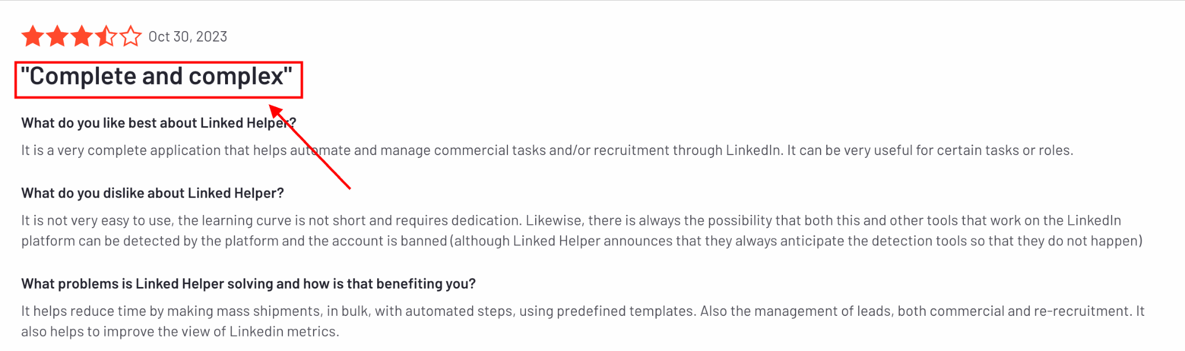

And that is the end of the list.

## Conclusion

Let us quickly wrap up this blog.

Picking the right **LinkedIn auto connect tool** comes down to **what you need and your budget.**

**If you are on a tight budget?**

**↪ Linked Helper 2** is simple, affordable, and gets the job done.

**If you want something that works even when your computer is off?**

**↪** Go for **Dripify**—it’s budget-friendly and super handy.

**If you need to do outreach on LinkedIn *and* other platforms?**

**↪ Meet Alfred** or **LaGrowthMachine** are great choices.

But if you want a tool that’s smooth, bug-free, and packed with powerful features, [**SalesRobot**](https://www.salesrobot.co/) is the way to go.

[**SalesRobot**](https://www.salesrobot.co/) offers a [14-day free trial](http://app.salesrobot.co/register), and you don’t even need a credit card to try it!

<Mobile CTA>